Assignment No:1
Name: Prutha Ranjit Sawale
Class: CS(AI)- B
Roll no.: 18
PRN: 12310272

Title: Setting up a small network (2PC/4 PC) and configuration for sharing resources.
Problem Statement: Setting up small wired computer network: Set up a small wired network of 2 to 4 computers using Hub/Switch/. It includes Preparation of Cables and setting up wired network.
Course Objective: To learn transmission mediums, networking devices and topologies used in the Internet.
Course Outcome: Select topology, essential components of physical layer and networking devices to design computer networks.
Tools Required: Computer, LAN Cards, RJ-45 Connectors, Hub/Switch, CAT-5 Cable, Cable tester, Crimping tool, etc.
Photos:

Theory:
1. Introduction:
Computer Networks, the widespread sharing of information among groups of computers and their users, a central part of the information age. The popular adoption of the personal computer (PC) and the local area network (LAN) during the 1980s has led to the capacity to access information on a distant database; download an application from overseas; send a message to a friend in a different country; and share files with a colleague—all from a personal computer. The networks that allow all this to be done so easily are sophisticated and complex entities. They rely for their effectiveness on many cooperating components. The design and deployment of the worldwide computer network can be viewed as one of the great technological wonders of recent decades.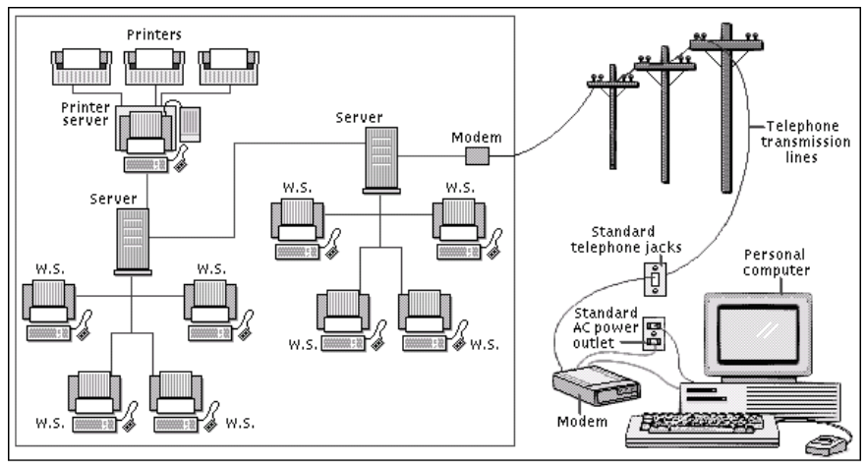
Fig 1.1. Computer Network
Networks are connections between groups of computers and associated devices that allow users to transfer information electronically. The local area network shown on the left is representative of the setup used in many offices and companies. Individual computers, called work stations (WS), communicate to each other via cable or telephone line linking to servers. Servers are computers exactly like the WS, except that they have an administrative function and are devoted entirely to monitoring and controlling WS access to part or all of the network and to any shared resources (such as printers). The red line represents the larger network connection between servers, called the backbone; the blue line shows local connections. A modem (modulator/demodulator) allows computers to transfer information across standard telephone lines. Modems convert digital signals into analogue signals and back again, making it possible for computers to communicate, or network, across thousands of miles.
2. Network Devices:
2.1 NIC (Network Interface Card): Each computer includes the File server or a Network will have a card plugged in the PCI Expunction slot or will have on-board NIC (Network Interface Card), which will provideConnectivity among the workstation in the network through cables.
Types of Cards:  Arc net card (2.5mbits/sec)  Ethernet card (10/100mbps)  Token Ring card (4-16mbits/sec) | 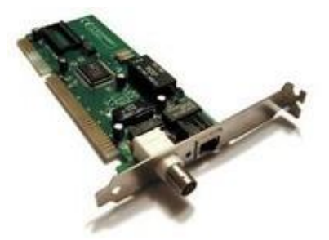  Fig 1.2. NIC Card

2.2 Hub
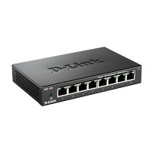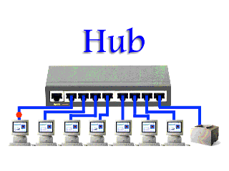
Fig 1.3. Hub
Hub is a central device that splits the network connection into multiple devices. When computer requests for information from a computer, it sends the request to the Hub. Hub distributes this request to all the interconnected computers.
There are three types of the hub that are given below:
- Passive Hub
- Active Hub
- Intelligent Hub
Passive Hub: The passive hubs are the connection point for wires that helps to make the physical network. It is capable of determining the bugs and faulty hardware. Simply, it accepts the packet over a port and circulates it to all ports. It includes connectors (10base-2 port and RJ-45) that can be applied as a standard in your network. This connector is connected to all local area network (LAN) devices. Additionally, the advanced passive hubs have AUI ports, which are connected as the transceiver according to the network design.
Active Hub: As compared to a passive hub, it includes some additional features. It is able to monitor the data sent to the connected devices. It plays an important role between the connected devices with the help of store technology, where it checks the data to be sent and decides which packet to send first.
It has the ability to fix the damaged packets when packets are sending, and also able to hold the direction of the rest of the packets and distribute them. If a port receives a weak signal, but still it is readable, then the active hub reconstructs the weak signal into a stronger signal before its sending to other ports. It can boost the signal if any connecting device is not working in the network. Therefore, it helps to make the continuity of services in LAN.
Intelligent Hub: It is a little smarter than passive and active hubs. These hubs have some kinds of management software that help to analyze the problem in the network and resolve them. It is beneficial to expend the business in networking; the management can assign users that help to work more quickly and share a common pool efficiently by using intelligent hubs. However, it offers better performance for the local area network. Furthermore, with any physical device, if any problem is detected, it is able to detect this problem easily.
Features of Hub
- It acts with shared bandwidth and broadcasting.
- It includes only one collision domain and broadcast domain.
- It works at the physical layer of the OSI model and also offers support for half-duplex transmission mode.
- It cannot create a virtual LAN and does not support spanning tree protocol.
- Furthermore, mainly packet collisions occur inside the hub.
- It also has a feature of flexibility, which means it includes a high transmission rate to different devices.
Applications of Hub
The important applications of a hub are given below:
- Hub is used to create small home networks.
- It is used for network monitoring.
- They are also used in organizations to provide connectivity.
- It can be used to create a device that is available thought out of the network.

2.3 Bridge
A Bridge is a kind of networking device that interconnects two or more networks together by dividing LAN into different segments. For this purpose it uses forwarding database or a bridge table. Unlike hubs, bridges does not simply broadcast traffic it effectively manages and it broadcasts traffic to network segments. Moreover it functions at datalink layer of the OSI model.
A bridge can be used in computer networks to interconnect two LANs together and separate network segments. Recall that a segment is a section of a network separated by bridges, switches, and routers. The bridge is a layer 2 device in the OSI model, meaning that it uses the MAC address information to make decisions regarding forwarding data packets. Only the data that needs to be sent across the bridge to the adjacent network segment is forwarded. This makes it possible to isolate or segment the network data traffic
Advantages of Bridges
- Network Extend : Sometimes bridges act as repeaters to extend a network. Networks with different architectures can be connected together using bridges.
- Increased Bandwidth: Few of the nodes present on a network share a separate collision domain. For these individual nodes, bridges increases bandwidth.
- High Reliability: Overall the network reliability is basically high in a bridge which makes it easier to maintain the network. And also network congestion can be reduced by dividing LAN into small segments.
- Frame Buffering : Different segments uses different MAC protocols. As a result it creates frame buffers. Therefore, bridges works to interconnect different segments.
- Protocol Transparency : Bridges generally functions at the MAC layer. This makes higher levels of protocol transparent.

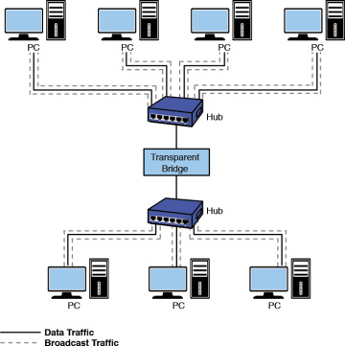
Fig 1.4. Bridge
Disadvantages of Bridges
- Cost: On average a bridge costs more than the hub and repeaters. That is the reason why it is only preferred when there is LAN network traffic load. In other situations of variable data load it is advisable to use either a hub or a repeater.
- Speed : A bridge does more buffering of frames and introduce more relays. This makes them slower compare to a repeater.
- Network Performance : Since bridges make extra processing by viewing all of the MAC addresses, they can potentially downgrade network performance.
- Broadcast Filtering : Bridges cannot individually filter the broadcast traffic. They simply forward broadcast packets.
- Broadcast Storms : Another downfall of simply forwarding broadcast traffic is that they can situation known as broadcast storms. Broadcast storms are nothing but high amount of broadcast traffic.

2.4 Switches
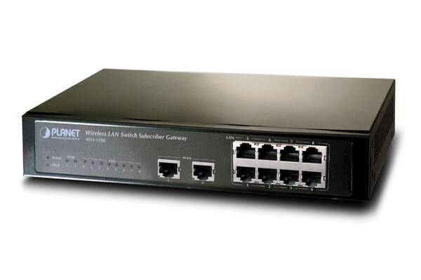
Fig 1.5. Switch
Switch is a networking device that groups all the devices over the network to transfer the data to another device. A switch is better than Hub as it does not broadcast the message over the network, i.e., it sends the message to the device for which it belongs to. Therefore, we can say that switch sends the message directly from source to the destination. It is networking device which transfers data only to the host where it is being addressed. It checks the destination address to route the packet appropriately. Following are features of the network switches.
- It operates at layer-2 (data link layer).
- It is available in various configurations and as per data transfer speeds such as 10/100/1000 Mbps or 10/100 Gbps.
- Operates in full duplex mode
- Packet collision is avoided due to port to port data transmission.
Advantages of Switches
Following are the benefits or advantages of Switches:
- They increase the available bandwidth of the network.
- They help in reducing workload on individual host PCs.
- They increase the performance of the network.
- Networks which use switches will have less frame collisions. This is due to the fact that switches create collision domains for each connection.
- Switches can be connected directly to workstations.=
Disadvantages of Switches
Following are the disadvantages of Switches:
- They are more expensive compare to network bridges.
- Network connectivity issues are difficult to be traced through the network switch.
Broadcast traffic may be troublesome.
- If switches are in promiscuous mode, they are vulnerable to security attacks e.g. spoofing IP address or capturing of ethernet frames.
- Proper design and configuration is needed in order to handle multicast packets.
While limiting broadcasts, they are not as good as routers.
  - Router
This networking device provides interconnection between two dissimilar networks. It operates at layer-3 of OSI stack and takes care of routing of packets based on routing table. It uses IP addressing for routing the packets. The IP address of each hosts contain two parts viz. network address and host address. The router checks destination host address, source host address and network address in order to route IP packet appropriately. Refer TCP-IP Packet format to know about various fields and their purpose in the networking system. A router is a device like a switch that routes data packets based on their IP addresses. The router is mainly a Network Layer device. Routers normally connect LANs and WANs together and have a dynamically updating routing table based on which they make decisions on routing the data packets. Router divide broadcast domains of hosts connected through it.
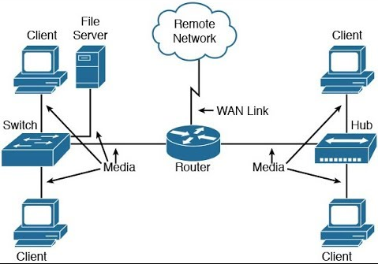
Fig 1.6. Router

Benefits or advantages of Routers
Following are the benefits or advantages of Routers:
- It provides connection between different network architectures such as ethernet & token ring etc.
- It can choose best path across the internetwork using dynamic routing algorithms.
- It can reduce network traffic by creating collision domains and also by creating broadcast domains.
- It provides sophisticated routing, flow control and traffic isolation.
- They are configurable which allows network manager to make policy based on routing decisions.
Drawbacks or disadvantages of Routers
Following are the drawbacks or disadvantages of Routers:
- They operate based on routable network protocols.
- They are expensive compare to other network devices.
- Dynamic router communications can cause additional network overhead. This results into less bandwidth for user data.
- They are slower as they need to analyze data from layer-1 through layer-3.
- They require considerable amount of initial configurations.
- They are protocol dependent devices which must understand the protocol they are forwarding.

3. Paring Rules and Colour Code:
The CAT 5 Cable consist of 8 wires which comes pares of White/Orange, Orange, White/Green, Green, White/Brown, Brown and they are coded for Straight and Cross combinations respectively.
Table 1. Straight Cable Paring
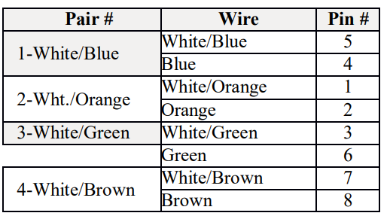

Table 2. Cross Cable Paring
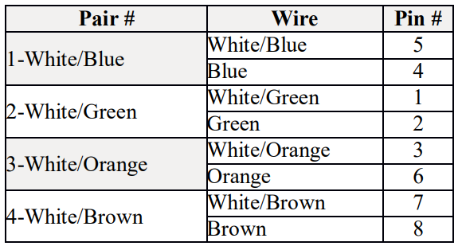
3.1 Connections among devices:-
Node to Node - Straight – Cross,
Switch to Node -Straight – Straight,
Switch to Switch -Straight –Cross.

3.3 How to Crimp a Cat 5 cable with RJ 45 Connector:-
- Skin off the cable jacket approximately 1" or slightly more.
- Un-twist each pair, and straighten each wire between the fingers.
- Place the wires in the order of one of the diagrams shown above .Bring all of the wires together, until they touch.
- At this point, recheck the wiring sequence with the diagram.
- Optional: Make a mark on the wires at 1/2" from the end of the cable jacket.
- Hold the grouped (and sorted) wires together tightly, between thumb and the thumb, and the forefinger.
- Cut all of the wires at a perfect 90 degree angle from the cable at 1/2" from the end of the cable jacket. This is a very critical step .If the wires are not cut straight, they may not all make contact. We suggest using a pair of scissors for this purpose.
- Conductors should be at a straight 90 degree angle, and be 1/2" long, prior to insertion into the connector.
- Insert the wires into the connector (pins facing up).
- Push moderately hard to assure that all of the wires have reached the end of the connector. Be sure that the cable jacket goes into the back of the connector by about3/16".
- Place the connector into a crimp tool, and squeeze hard so that the handle reaches its full swing.
- Repeat the process on the other end. For a straight through cable, use the same wiring.
- Use a cable tester to test for proper continuity.

3.4 Cable Testing Tool:
It is a tool used for testing weather there is no cut in between two terminals and to identify the type of pair crimp with.

4. Transmission Media:
On any network, the various entities must communicate through some form of media. Just as humans can communicate through telephone wires or sound waves in the air, computers can communicate through cables, light, and radio waves. Transmission media enable computers to send and receive messages but do not guarantee that the messages will be understood. Most common network transmission media are coaxial cable, shielded twisted-pair cable, and unshielded twisted-pair cable, fiber-optic cable and wireless communications.
Select the appropriate media for various situations. Media choices include the following:
• Twisted-pair cable
• Coaxial cable
• Fiber-optic cable
Wireless communications Situational elements include the following:
• Cost
• Distance limitations
• Number of nodes

4.1 Types of transmission media
In data communication terminology, a transmission medium is a physical path between the transmitter and the receiver i.e it is the channel through which data is sent from one place to another. Transmission Media is broadly classified into the following types.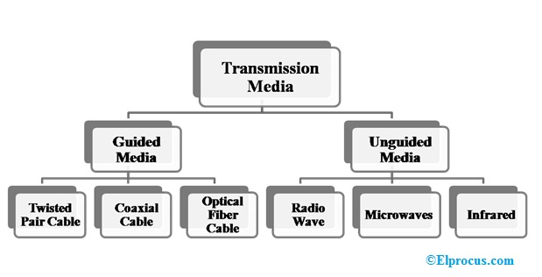
Fig 1.7 . Types of transmission media

Twisted pair
Twisted pair is a physical media made up of a pair of cables twisted with each other. A twisted pair cable is cheap as compared to other transmission media. Installation of the twisted pair cable is easy, and it is a lightweight cable. The frequency range for twisted pair cable is from 0 to 3.5KHz.
A twisted pair consists of two insulated copper wires arranged in a regular spiral pattern. The degree of reduction in noise interference is determined by the number of turns per foot. Increasing the number of turns per foot decreases noise interference.
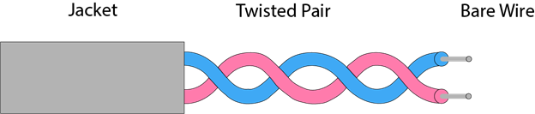
Fig 1.8. Twisted pair
Coaxial cable
Coaxial cable gets its name because it contains two conductors that are parallel to each other. The center conductor in the cable is usually copper. The copper can be either a solid wire or stranded martial. Outside this central Conductor is a non-conductive material. It is usually white, plastic material used to separate the inner Conductor form the outer Conductor. The other Conductor is a fine mesh made from Copper. It is used to help shield the cable form EMI.

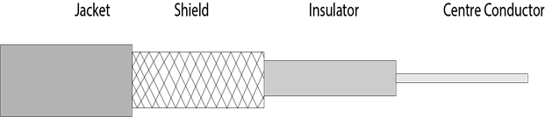
Fig 1.9. Coaxial cable

Fiber Optic Cable
These are similar to coaxial cable. It uses electric signals to transmit data. At the centre is the glass core through which light propagates. In multimode fibres, the core is 50microns, and In single mode fibres, the thickness is 8 to 10 microns. The core in fiber optic cable is surrounded by glass cladding with lower index of refraction as compared to core to keep all the light in core. This is covered with a thin plastic jacket to protect the cladding. The fibers are grouped together in bundles protected by an outer shield
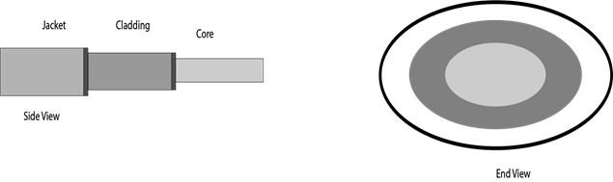
Fig 1.10. Fiber Optic Cable
5. Network Topology
Computers in a network have to be connected in some logical manner. The layout pattern of the interconnections between computers in a network is called network topology.
5.1 Bus topology
Bus topology uses one main cable to which all nodes are directly connected. The main cable acts as a backbone for the network. One of the computers in the network typically acts as the computer server. The first advantage of bus topology is that it is easy to connect a computer or peripheral device. The second advantage is that the cable requirements are relatively small, resulting in lower cost. One of the disadvantages is that if the main cable breaks, the entire network goes down. This type of network is also difficult to troubleshoot. For these reasons, this type of topology is not used for large networks.
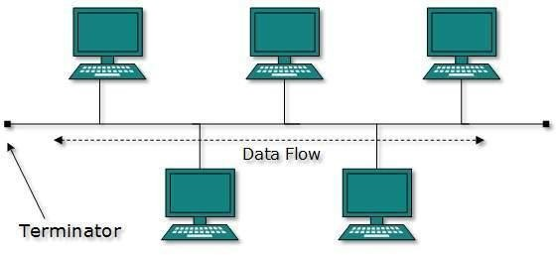
Fig 1.11. Bus topology
Advantages of Bus Topology
- It is easy to set up, handle, and implement.
- It is best-suited for small networks.
- It costs very less.
Disadvantages of Bus Topology
- The cable length is limited. This limits the number of network nodes that can be connected.
- This network topology can perform well only for a limited number of nodes. When the number of devices connected to the bus increases, the efficiency decreases.
- It is suitable for networks with low traffic. High traffic increases load on the bus, and the network efficiency drops.
- It is heavily dependent on the central bus. A fault in the bus leads to network failure.
- It is not easy to isolate faults in the network nodes.
- Each device on the network “sees” all the data being transmitted, thus posing a security risk.
5.2 Star topology
In star topology, each computer is connected to a central hub using a point-to-point connection. The central hub can be a computer server that manages the network, or it can be a much simpler device that only makes the connections between computers over the network possible. Star topology is very popular because the startup costs are low. It is also easy to add new nodes to the network. The network is robust in the sense that if one connection between a computer and the hub fails, the other connections remain intact. If the central hub fails, however, the entire network will fail.
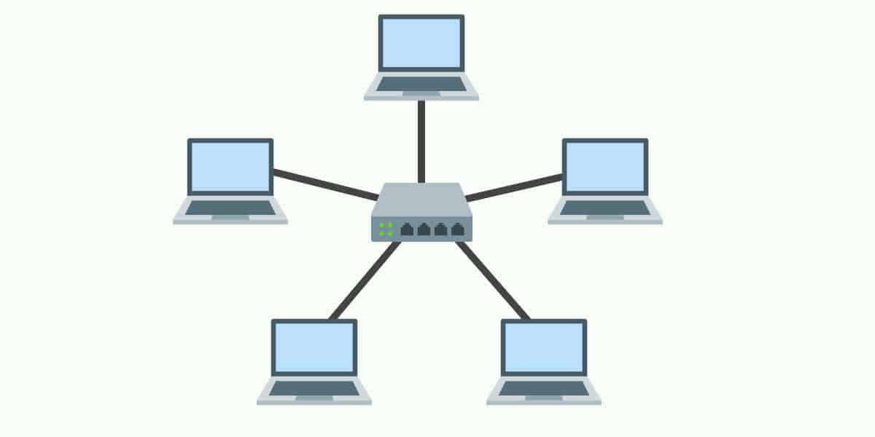
Fig 1.12. Star topology
Advantages of Star Topology
- Due to its centralized nature, the topology offers simplicity of operation.
- It also achieves isolation of each device in the network.
- Adding or removing network nodes is easy, and can be done without affecting the entire network.
- Due to the centralized nature, it is easy to detect faults in the network devices.
- As the analysis of traffic is easy, the topology poses lesser security risk.
- Data packets do not have to pass through many nodes, like in the case of a ring network. Thus, with the use of a high-capacity central hub, traffic load can be handled at fairly decent speeds.
Disadvantages of Star Topology
- Network operation depends on the functioning of the central hub. Hence, central hub failure leads to failure of the entire network.
- Also, the number of nodes that can be added, depends on the capacity of the central hub.
- The setup cost is quite high.

5.3 Ring topology
In ring topology, the computers in the network are connected in a circular fashion, and the data travels in one direction. Each computer is directly connected to the next computer, forming a single pathway for signals through the network. This type of network is easy to install and manage. If there is a problem in the network, it is easy to pinpoint which connection is defective. It is also good for handling high-volume traffic over long distances since every computer can act as a booster of the signal. On the downside, adding computers to this type of network is more cumbersome, and if one single computer fails, the entire network goes down.
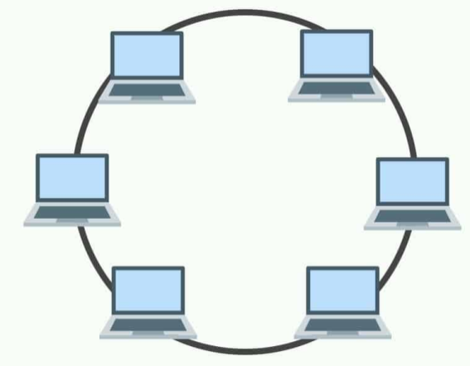
Fig 1.13. Ring topology:
Advantages of Ring Topology
- The data being transmitted between two nodes passes through all the intermediate nodes. A central server is not required for the management of this topology.
- The traffic is unidirectional and the data transmission is high-speed.
- In comparison to a bus, a ring is better at handling load.
- The adding or removing of network nodes is easy, as the process requires changing only two connections.
- The configuration makes it easy to identify faults in network nodes.
- In this topology, each node has the opportunity to transmit data. Thus, it is a very organized network topology.
- It is less costly than a star topology.
Disadvantages of Ring Topology
- The failure of a single node in the network can cause the entire network to fail.
- The movement or changes made to network nodes affect the entire network’s performance.
- Data sent from one node to another has to pass through all the intermediate nodes. This makes the transmission slower in comparison to that in a star topology. The transmission speed drops with an increase in the number of nodes.
- There is heavy dependency on the wire connecting the network nodes in the ring.

5.4 Mesh topology
In mesh topology, every node has a direct point-to-point connection to every other node. Because all connections are direct, the network can handle very high-volume traffic. It is also robust because if one connection fails, the others remain intact. Security is also high since data travels along a dedicated connection.
Mesh topology can be formed by using the formula:
Number of cables = (n*(n-1))/2; Where n is the number of nodes that represents the network

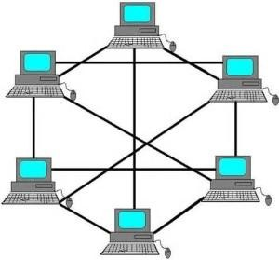
Fig 1.14. Mesh topology
Advantages of Mesh Topology
- The arrangement of the network nodes is such that it is possible to transmit data from one node to many other nodes at the same time.
- The failure of a single node does not cause the entire network to fail as there are alternate paths for data transmission.
- It can handle heavy traffic, as there are dedicated paths between any two network nodes.
- Point-to-point contact between every pair of nodes, makes it easy to identify faults.
Disadvantages of Mesh Topology
- The arrangement wherein every network node is connected to every other node of the network, many connections serve no major purpose. This leads to redundancy of many network connections.
- A lot of cabling is required. Thus, the costs incurred in setup and maintenance are high.
- Owing to its complexity, the administration of a mesh network is difficult.

5.5 Tree topology
A tree topology is a special type of structure where many connected elements are arranged like the branches of a tree. For example, tree topologies are frequently used to organize the computers in a corporate network, or the information in a database.
In a tree topology, there can be only one connection between any two connected nodes. Because any two nodes can have only one mutual connection, tree topologies create a natural parent and child hierarchy.
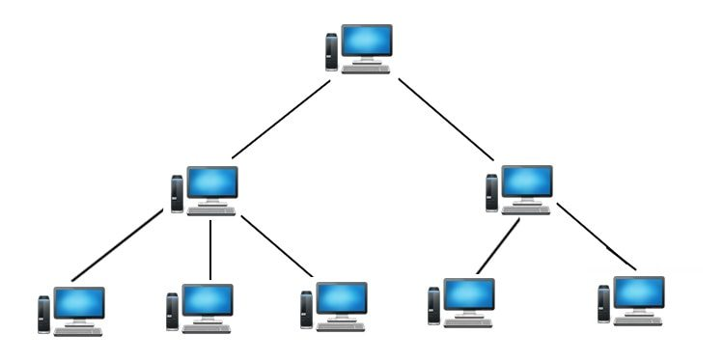
Fig 1.15. Tree Topology

Advantages of Tree Topology
- The tree topology is useful in cases where a star or bus cannot be implemented individually. It is most-suited in networking multiple departments of a university or corporation, where each unit (star segment) functions separately, and is also connected with the main node (root node).
- The advantages of centralization that are achieved in a star topology are inherited by the individual star segments in a tree network.
- Each star segment gets a dedicated link from the central bus. Thus, failing of one segment does not affect the rest of the network.
- Fault identification is easy.
- The network can be expanded by the addition of secondary nodes. Thus, scalability is achieved.
Disadvantages of Tree Topology
- As multiple segments are connected to a central bus, the network depends heavily on the bus. Its failure affects the entire network.
- Owing to its size and complexity, maintenance is not easy and costs are high. Also, configuration is difficult in comparison to that in other topologies.
- Though it is scalable, the number of nodes that can be added depends on the capacity of the central bus and on the cable type.

5.6 Hybrid Topology
The combination of various different topologies is known as Hybrid topology. A Hybrid topology is a connection between different links and nodes to transfer the data. When two or more different topologies are combined together is termed as Hybrid topology and if similar topologies are connected with each other will not result in Hybrid topology. For example, if there exist a ring topology in one branch of ICICI bank and bus topology in another branch of ICICI bank, connecting these two topologies will result in Hybrid topology.
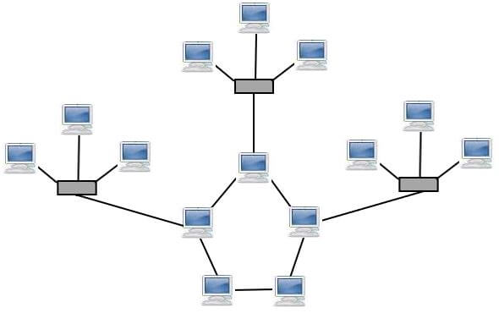
Fig 1.16. Hybrid Topology

Conclusion: Hence, we have successfully setup small network to share resources.

